Admin

1. As an admin I have rejected this vehicle Vehicle No.. “TS 12345HH” but still as an owner I can see them as available

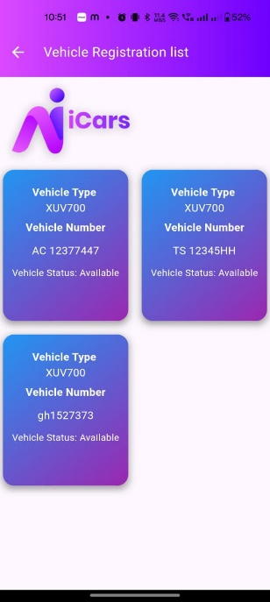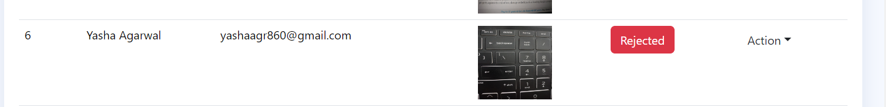

2. The 4th card vehicle type is bike here its showing “Gt 650 “ without entering the bike images the the vehicle is showing as available and admin is able to approve .. and even as a renter I am able to see this vehicle and I am allowed to book 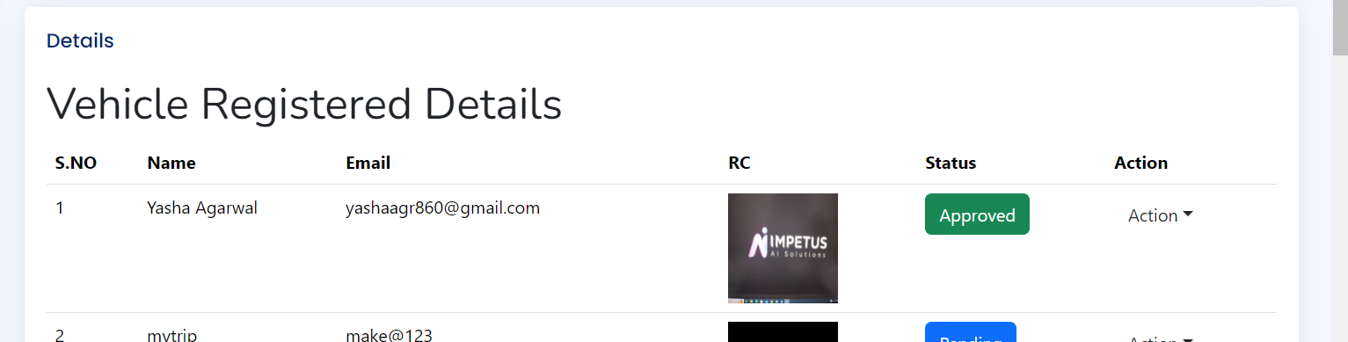

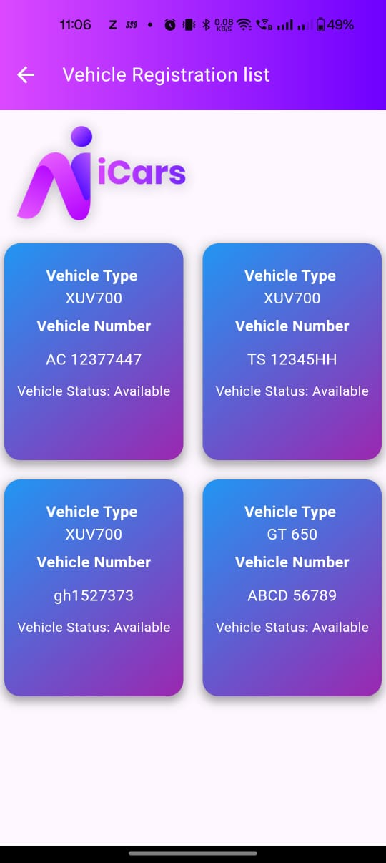

3. Still the dropdown for pickup location & drop location is not there.

4. After adding bank account details as an owner still in the landing page the option for add bank details is showing

5. Owner cannot submit their vehicle without car images & Bank account detail

6. as an owner without entering my bank account details and car images the admin should not be able to approve the vehicle .... and on rejection the popup is showing as approved successfully

7. Unable to book vehicle as an renter..if the car is already booked then it should not show in the list for booking.

8. as a renter if i am chnaging the time and date of booking then it should be prepopulated first

9. Spelling Mistake login as “car renter” not rental and booking date and time “Change” not Cahnge and booking status will be “pending” not panding

10. unable to edit the pickup & drop time …after edit the page is going somewhere else

11. as an renter unable to see the pickup & drop location of the vehicle .

12. on approving the booking request no fileds for entering comments are showing

13. current approved vehicle should come to the top

14. my profile page for renter is not working – part of usecase 7

15. view profile as an owner not working

16. From usecase 10-13 is still pending

12. unable to see all these fields while bboking the car as an renter 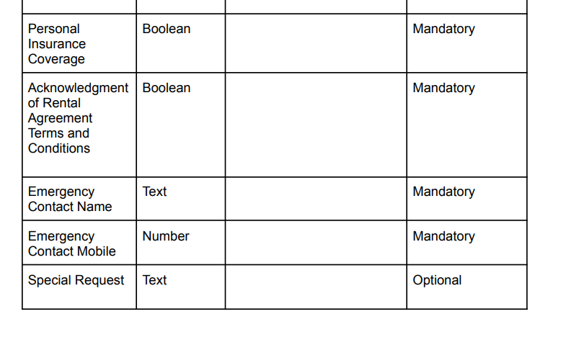

13. after selecting the date & time why again its asking for name and mobile no as an renter