Bango Backend Changes

## **BDM**

We Just need these features for BDM

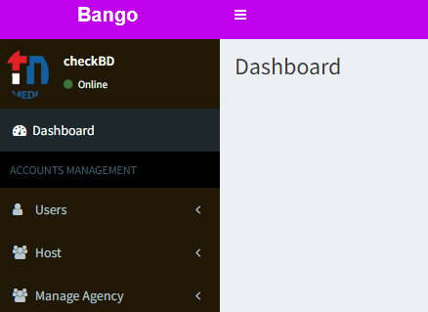

No one should have these features access except Master Panel

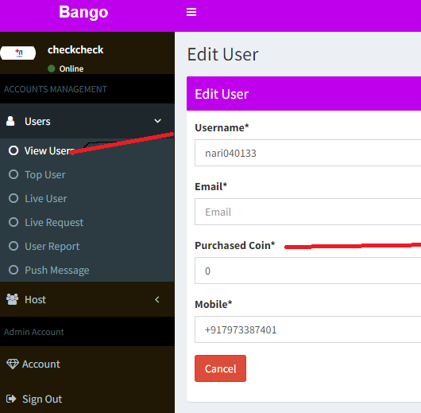

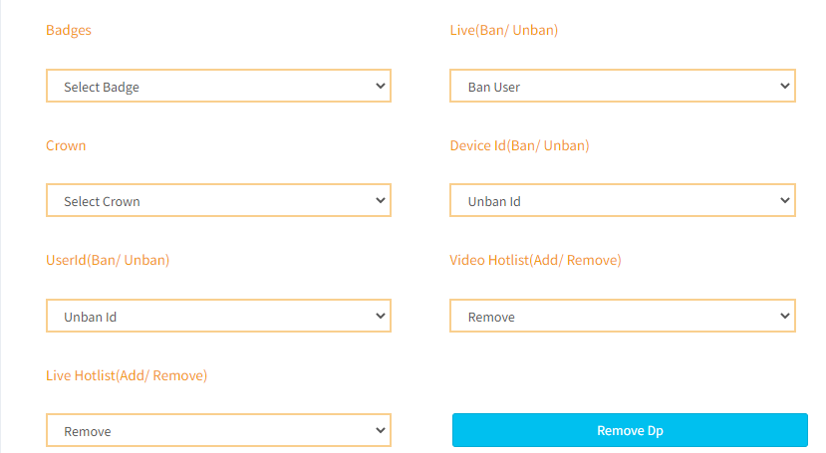

=====================================================================================

We need one more panel for recruiters where they can just access agency reports