Bango Backend Changes

BDM

We Just need these features for BDM
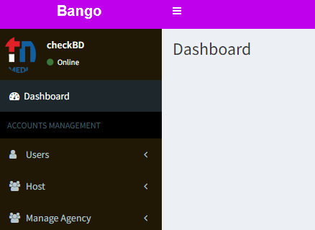

No one should have these features access except Master Panel
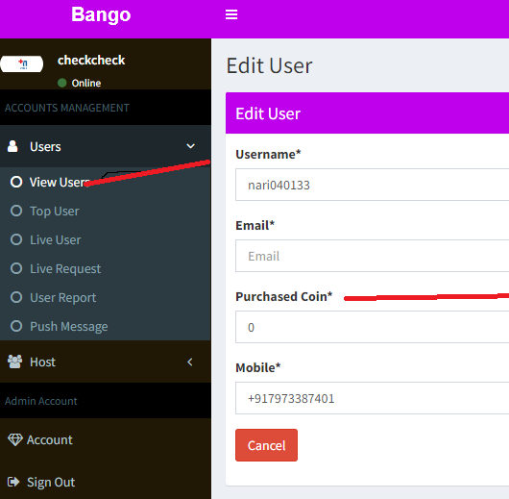
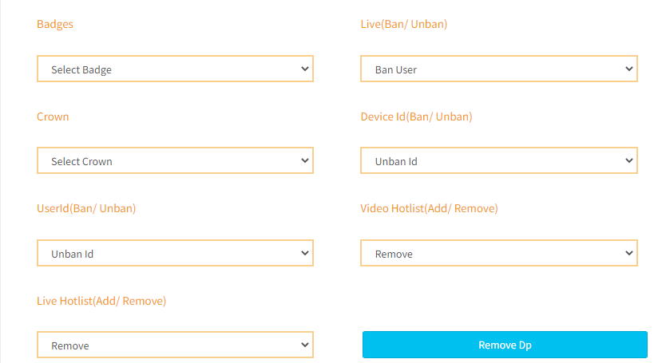
=====================================================================================

We need one more panel for recruiters where they can just access agency reports

